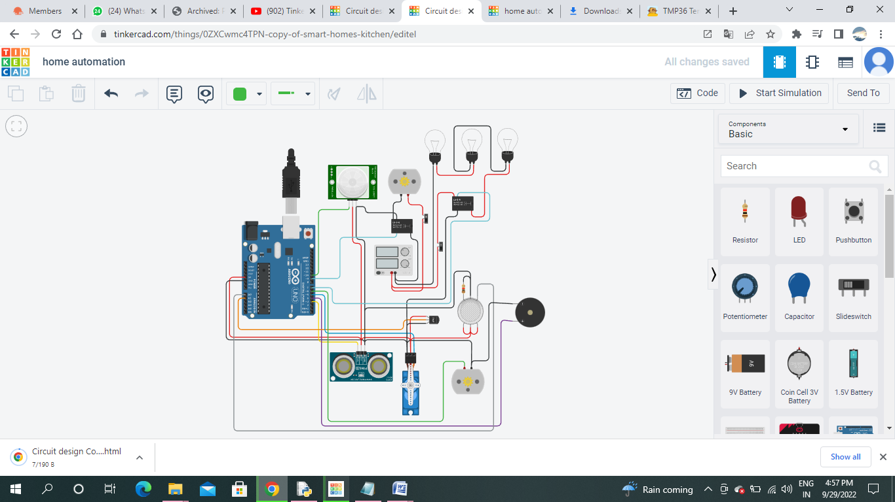Circuit connections:

Code:

#include <Servo.h>

int Cabinet = 0;

int PIRS = 0;

int Gass = 0;

int Temps = 0;

long readUltrasonicDistance(int triggerPin, int echoPin)

{

pinMode(triggerPin, OUTPUT); // Clear the trigger

digitalWrite(triggerPin, LOW);

delayMicroseconds(2);

// Sets the trigger pin to HIGH state for 10 microseconds

digitalWrite(triggerPin, HIGH);

delayMicroseconds(10);

digitalWrite(triggerPin, LOW);

pinMode(echoPin, INPUT);

// Reads the echo pin, and returns the sound wave travel time in microseconds

return pulseIn(echoPin, HIGH);

}

Servo servo_5;

void setup()

{

Serial.begin(9600);

servo_5.attach(5, 500, 2500);

pinMode(10, INPUT);

pinMode(9, OUTPUT);

pinMode(7, OUTPUT);

pinMode(A1, INPUT);

pinMode(6, OUTPUT);

pinMode(A0, INPUT);

pinMode(4, OUTPUT);

}

void loop()

{

Cabinet = 0.01723 * readUltrasonicDistance(3, 3);

Serial.println(Cabinet);

if (Cabinet < 15) {

servo_5.write(90);

delay(5000); // Wait for 5000 millisecond(s)

} else {

servo_5.write(0);

}

PIRS = digitalRead(10);

Serial.println(PIRS);

if (PIRS == HIGH) {

digitalWrite(9, HIGH);

digitalWrite(7, HIGH);

} else {

digitalWrite(9, LOW);

digitalWrite(7, LOW);

}

Temps = (-40 + 0.488155 * (analogRead(A1) - 20));

Serial.println(Temps);

if (Temps >= 30) {

digitalWrite(6, HIGH);

} else {

digitalWrite(6, LOW);

}

Gass = analogRead(A0);

Serial.println(Gass);

if (Gass >= 220) {

digitalWrite(4, HIGH);

} else {

digitalWrite(4, LOW);

}

}